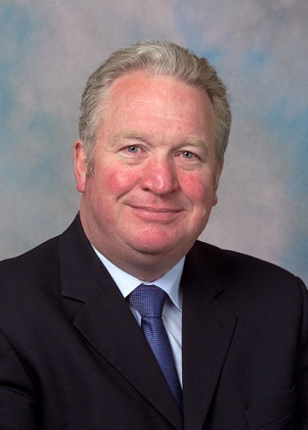
The Parliamentary Under Secretary of State for DWP, Minister for Disabled People, Mike Penning MP has agreed to be a guest speaker at our event at The Royal Overseas League on Monday 3rd February 2014 at 6pm. The address is:

Over-Seas House, Park Place, St. James’s Street, London, SW1A 1LR

Applications for tickets are open to all members, supporters and friends of the Conservative Party. To apply for tickets and secure a place at this prestigious event please send the slip below with payment to Conservative Disability Group, C/O David Tiptaft, CDG Treasurer at Marchman House, 3a West Street, Mexborough, South Yorkshire, S64 9HZ

Please note we can only accommodate a limited number of guests, on a first come first served basis. The contribution for the entry ticket is £20.00 per person to cover our costs.
_____________________________________________________________________________________

I wish to apply for ______(number of entry tickets) at £20.00 each
I enclose a total amount of £___________.

Name _________________________________________________

Address________________________________________________

Email Address:___________________________________________

Telephone Number_______________________________________

